Emotion Recognition from Speech: Handcrafted Acoustic Features with SVM Classification
Project: Emotion Recognition from Speech
Course: COMP‑SCI 5530: Principles of Data Science
Team Members:
- Tina Nguyen (@tinana2k)
- Diego Brown (@dsb4k8)
- Jainil Anilkumar Patel (@jainilpatel98)
- JoshaLynn Worth (@jrocks1561)

1. Introduction
This project focuses on automatic recognition of human emotions from speech using acoustic features. Speech emotion recognition is important for applications such as human-computer interaction and assistive technologies. The goal of this project is to develop a feature-based system that uses handcrafted features and a Support Vector Machine (SVM) to classify emotions from audio recordings.
2. Related Work
Recent approaches in speech emotion recognition primarily use deep learning models such as CNNs and transformer-based methods, which achieve high accuracy but require large datasets and computational resources. Hybrid approaches that combine deep representations with handcrafted features have also been explored to improve robustness. Traditional methods, including classifiers such as K-Nearest Neighbors (KNN), have been used with handcrafted features but generally achieve lower performance. In contrast, classical feature-based approaches remain effective in low-data settings due to their simplicity and interpretability. This project uses a feature-based approach with a Support Vector Machine (SVM) classifier as a baseline.
3. Methodology
Audio data from the RAVDESS dataset was preprocessed by converting to mono, resampling to 16 kHz, normalizing amplitude, and standardizing each clip to a fixed duration of 2 seconds. Handcrafted acoustic features, including MFCCs, spectral features, energy measures, and pitch-related features, were extracted and aggregated into fixed-length vectors. Features were standardized using statistics computed from the training set.
A Support Vector Machine (SVM) classifier was trained on the resulting feature vectors. Hyperparameters, including the regularization parameter C = 1 and class weights, were tuned to address class imbalance and optimize performance. An actor-wise split was used to prevent speaker overlap between training and testing. Basic data augmentation techniques (noise addition, time shifting, and amplitude scaling) were applied to the training data, with time shifting limited by fixed-length preprocessing.

3.1 Architecture Diagram

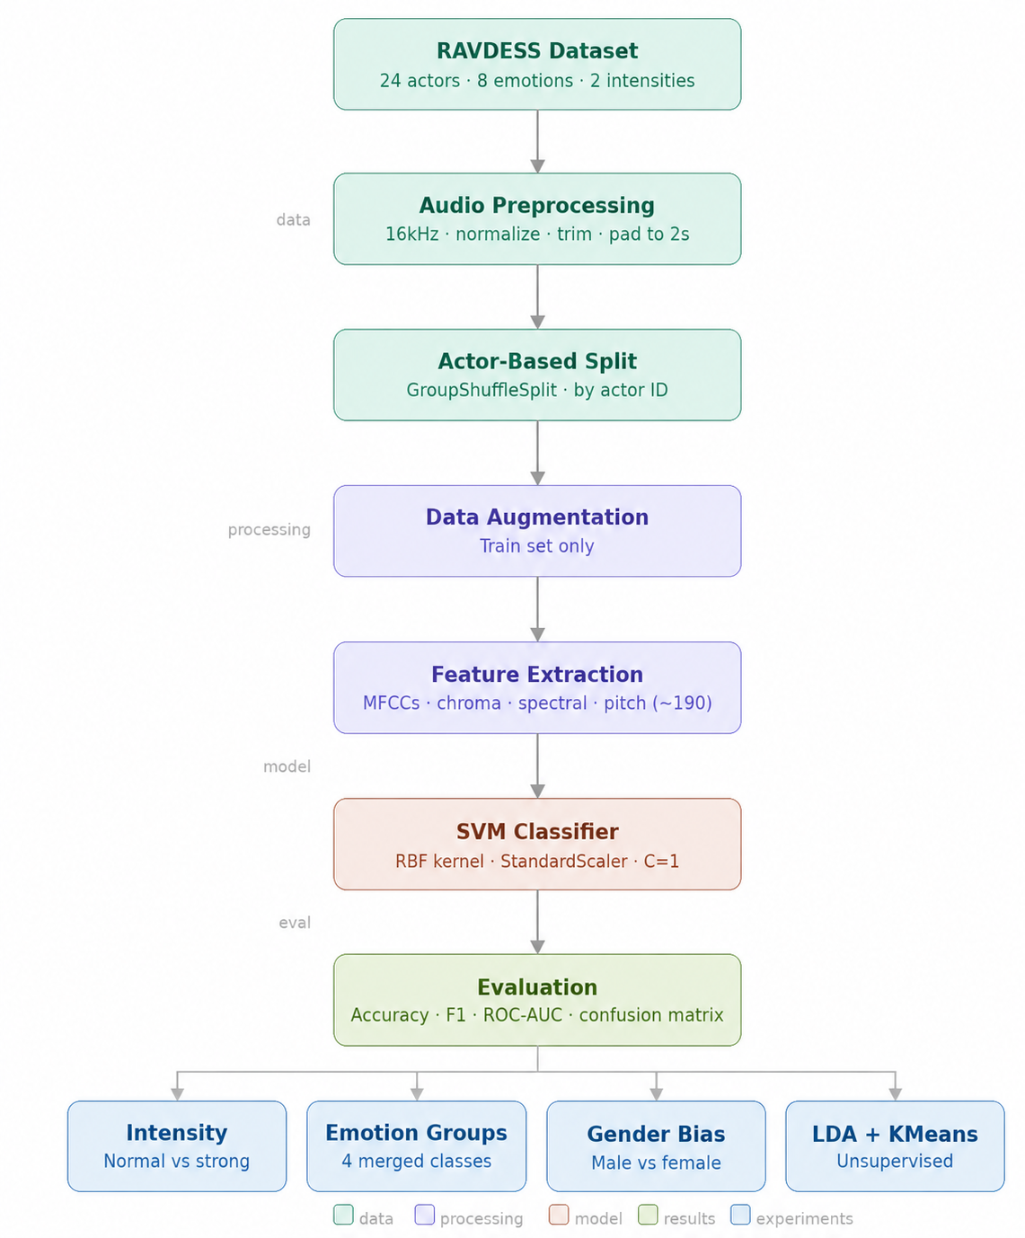

3.2 Handcrafted Features

The model uses a 199-dimensional handcrafted acoustic feature vector capturing temporal, spectral, and prosodic characteristics of speech.
Feature Group | Features Included | Dimension
Temporal & Spectral Energy | ZCR, RMS, spectral centroid, bandwidth, rolloff, flatness (mean, std, min, max) | 24
MFCC | 20 MFCCs + first and second derivatives (mean, std) | 120
Chroma | 12 pitch class features (mean, std) | 24
Spectral Contrast | 7 frequency bands (mean, std) | 14
Tonnetz | Tonal features (mean, std) | 12
Pitch & Voicing | Pitch statistics (mean, std, min, max) + voiced fraction | 5
Total |  | 199

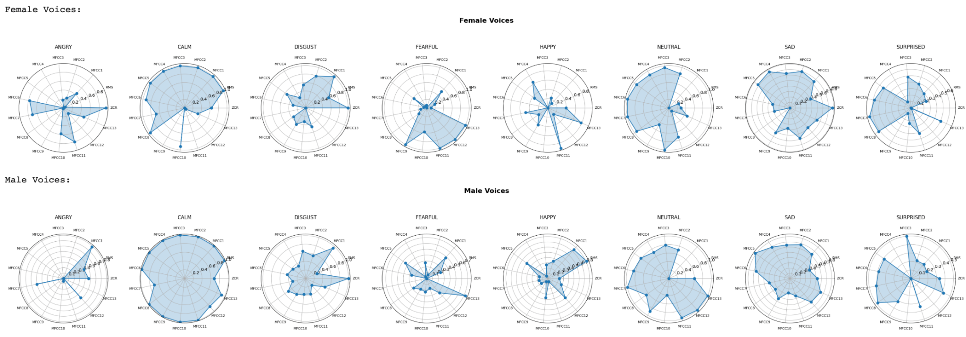
The Radial plot shows the distinguishing features that helps to determine the emotions.

4. Results and Discussion
The model achieved approximately 56% accuracy on emotion classification, with similar performance across normal and strong intensity samples. High-arousal emotions such as angry and surprised were recognized more reliably, while low-arousal emotions such as sad and fearful were frequently confused. Data augmentation did not improve performance. Grouping emotions into broader categories improved classification accuracy, indicating overlap between similar classes. Additionally, performance differed across gender, with higher accuracy for female voices than male voices, suggesting potential bias in the model.

4.1 Confusion Matrices
All 8 Emotions - Confusion Matrix
The confusion matrix shows class-wise performance for all eight emotions. Stronger predictions appear along the diagonal, while off-diagonal entries indicate confusion between similar emotions, particularly among low-arousal classes such as sad, calm, and neutral. We performed 5 fold cross validation for validating the model.
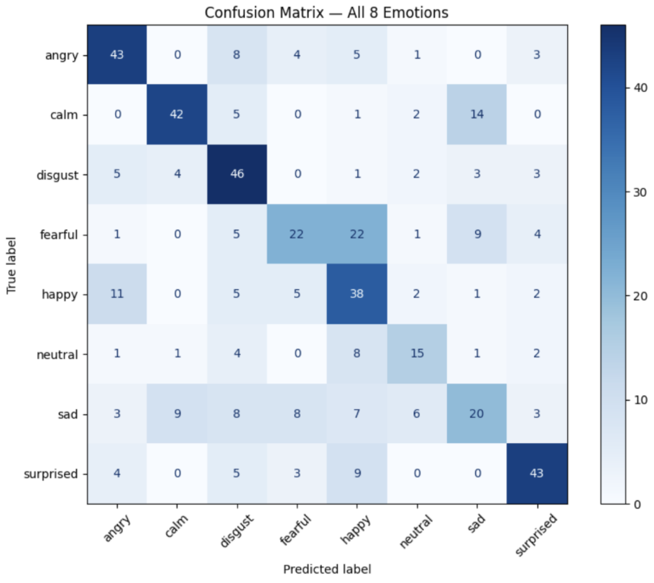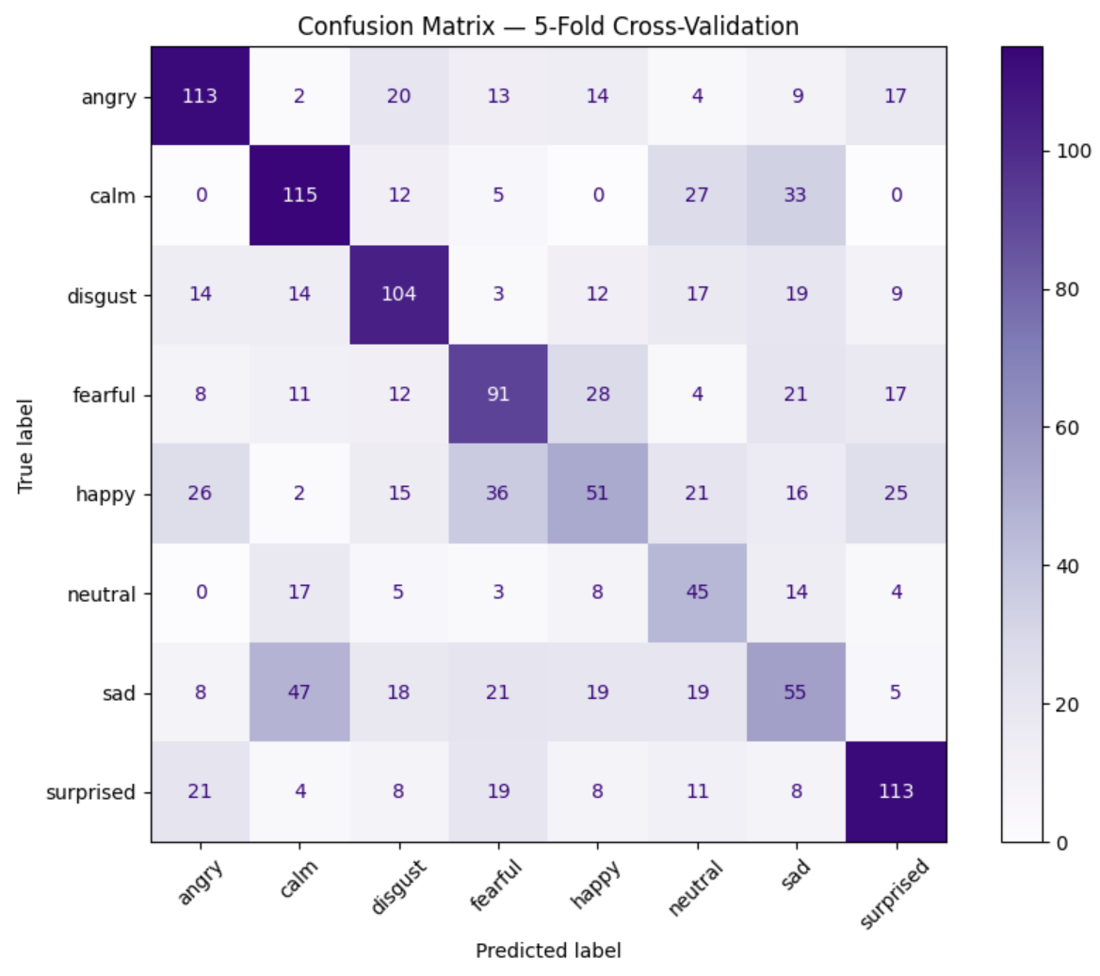
Combined Emotions - Confusion Matrix
Grouping emotions into broader categories improves classification performance slightly, as shown by stronger diagonal values. This indicates that many misclassifications occur between closely related emotion classes.
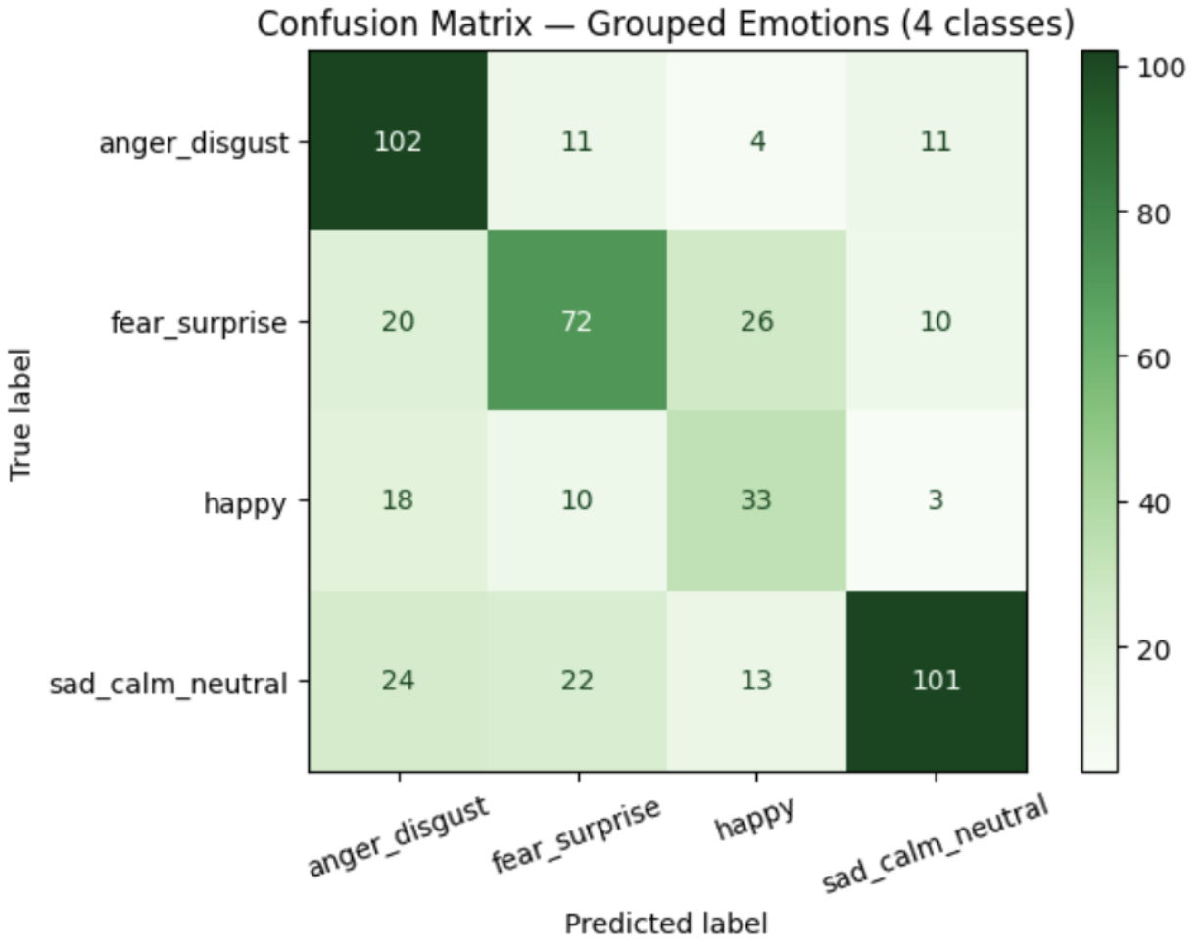
ROC Curve
The ROC curves illustrate the model’s ability to distinguish between emotion classes. Higher AUC values (e.g., calm and surprised) indicate better separation, while lower values (e.g., sad) reflect weaker performance.
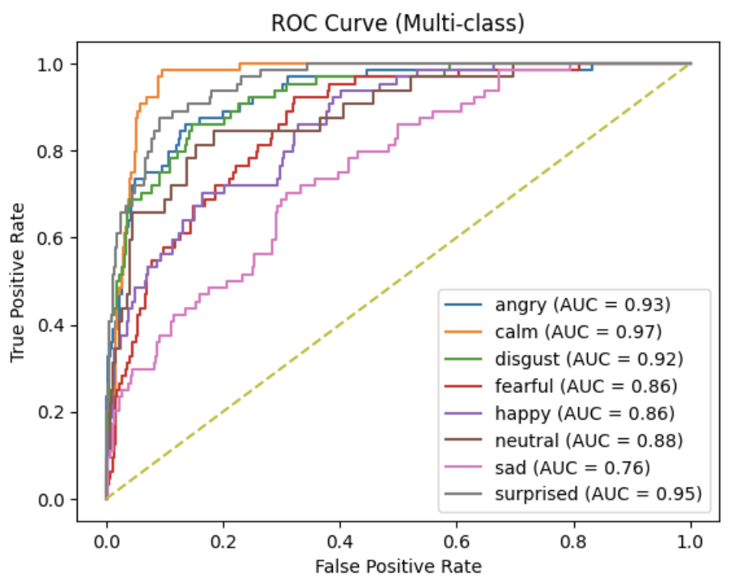
Gender Accuracy Chart
The model achieves higher accuracy on female voices (60.83%) than male voices (51.25%), indicating a potential gender-related performance gap.
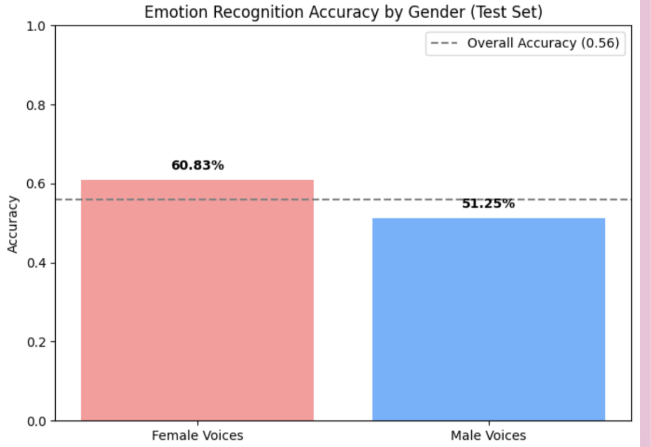
5. Conclusion and Future Work
This project implemented a feature-based speech emotion recognition system using a Support Vector Machine (SVM) classifier. Results show moderate performance, with challenges in distinguishing similar emotions due to overlapping acoustic characteristics. Future work could explore more advanced models, including deep learning approaches such as CNNs and transformer-based methods, as well as alternative classical models like Random Forests or K-Nearest Neighbors (KNN). Improvements could also be made through enhanced feature representations and more effective data augmentation strategies. Additionally, addressing the observed performance gap between male and female voices is important to improve fairness and model reliability. Evaluating the model on more diverse datasets would further strengthen generalisation.
6. Lesson Learned
- Using 2-second audio clips provided enough acoustic information to achieve moderate emotion classification performance while keeping the pipeline computationally efficient.
- Features can be created from the audio samples, and SVM can also be used to determine the category of the emotion. We don’t need to train heavy time series models such as LSTM.

